Article
Analysis of Voltage Deviation Improvement in Microgrid Operation through Demand Response using Imperialist Competitive and Genetic Algorithms
Mahdi Ghaffari ¹, Hamed H. Aly ^{2,}*
Citation: To be added by editorial staff during production.
Academic Editor: Firstname Lastname
Received: date
Revised: date
Accepted: date
Published: date

Copyright: © 2024 by the authors. Submitted for possible open access publication under the terms and conditions of the Creative Commons Attribution (CC BY) license (https://creativecommons.org/licenses/by/4.0/).
¹ mahdi.ghaffari@dal.ca
^{2,*} Correspondence: hamed.aly@dal.ca
Smart Grid and Green Power Systems Research Laboratory, Electrical and Computer Engineering Department, Dalhousie University, Halifax, NS, Canada

Abstract: In recent decades, with the expansion of distributed energy production technologies and increasing needs for more flexibility and efficiency in energy distribution systems, microgrids is considered as a promising innovative solution for local energy supply and enhancing resilience against network fluctuations. One of the basic challenges in the operation of microgrids is the optimal management of voltage and frequency in the network, which has been the subject of extensive research in the field of microgrid operational optimization.
Additionally, since energy demand changes over time, the use of demand response strategies is of great importance. These strategies enable better energy management in microgrids, thereby improving system efficiency and stability.
Given the complexity of optimization problems related to microgrid management, evolutionary optimization algorithms such as the Imperialist Competitive Algorithm (ICA) and Genetic Algorithm (GA) have gained great attention. These algorithms enable solving high-complexity optimization problems by considering various constraints and multiple objectives.
In this paper individual and hybrid of ICA and GA are used to check the effects of voltage division optimization in microgrids based on demand response strategies.
Keywords: Demand Response, Microgrid, Voltage division, ICA, GA

1. Introduction

Increasing the importance of microgrids is due to the increasing integration of power systems and distributed energy resources (DERs) for local energy supply. There are many advantages of microgrids including improving grid stability, increasing energy efficiency, and providing more flexibility in energy distribution. One of the challenges that can be mentioned due to the operational complexity of microgrids is the optimal management of voltage and frequency, which leads to ensuring the stability of the network and more effective performance of microgrids.

On the other hand, the demand for energy consumption is changing throughout the day and night, and it is necessary to implement strategies that can dynamically respond to these changes. One of these strategies that have been developed to manage energy consumption patterns in response to supply conditions is demand response (DR). By using DR strategies, microgrids can achieve better energy management and thus increase system efficiency and stability.

Evolutionary algorithms are advanced optimization techniques that are used to ease complex optimization problems related to microgrid management. ICA and GA have shown great potential in facing these challenges, which are able to solve difficult optimization problems in different constraints and multiple objectives. In this paper, we have used ICA and GA first individually and then combined them to create a hybrid algorithm that has all features of both algorithms to optimize voltage regulation in microgrids through load response strategies. The reduction of voltage deviations and the improvement of overall microgrid performance are to be evaluated, which can have significant impacts on the design and management of future microgrid systems and provide insights on how to use advanced optimization algorithms to improve microgrid stability and efficiency.

As mentioned, DR is one of the control and management tools of the power network that can be used to improve the operation of the grid. This tool has been used to reduce costs, improve losses and improve voltage deviation. For summary as a comparison with existing work:
- Cost-Benefit Analysis of DR Programs in Power Grids: This paper [1] explored the cost-benefit analysis of Demand Response (DR) programs using an open modeling framework, focusing on improving grid reliability and reducing operational costs. This paper provides a detailed analysis of how to improve power grid efficiency and reliability and reduce operating costs using DR programs
- Venkatesan et al. [2]: Developed a residential DR model and evaluated its impact on voltage profile and losses in distribution networks. This study uses a DR model to simulate the impact of different load control strategies on the distribution system. The results show that DR can significantly improve the voltage profile and reduce losses, with increased efficiency and reliability of the distribution network.
- Ullah et al. [3]: Shows strategies to increase the efficiency of microgrids through DR optimization and power sharing mechanisms. This study using the bee colony algorithm shows that it reduced both operational costs and power losses. In their proposed plan, they announced to the operator the amount of power they can increase or decrease along with their proposed price. Considering this, the operator executes the optimization program and obtains the best answer and announces it many times which is considered as a drawback for their work. In this article, the ICA and the GA are used individually and in combination to find the best possible solution.
- Le Thi et al. [4]: Compared various optimization algorithms including PSO-ANN, GA-ANN, ICA-ANN, and ABC-ANN for estimating heating loads in smart cities, highlighting the efficiency of hybrid approaches but not specifically targeting voltage deviation in microgrids​.
- Purlu & Turkay [5]: Employed heuristic methods for optimal allocation of renewable distributed generations to minimize energy losses and voltage deviation, though not specifically integrating DR strategies​.

This work’s contributions can be summarized in the following three main points:
- Hybrid Optimization: Hybrid model ICA and GA is proposed to leverage the strengths of both algorithms which helps in achieving better convergence and solution accuracy.
- Dynamic DR Strategies: Our approach dynamically adjusts load based on real-time demand and supply conditions, enhancing voltage stability.
- Comprehensive Evaluation: The proposed work is implemented on a 33-Bus IEEE sample network and demonstrated significant improvements in voltage profiles compared to individual and traditional optimization methods.

The work structure comprises five sections, covering the concept of DR, the proposed method, simulation results, and concluding remarks, with a focus on the technical and comprehensive exploration of DR in microgrid management.
  - DEMAND RESPONSE

DR programs include methods of Demand Side Management (DSM), which refers to the change in the consumption of customers due to the change in the price of electricity in the market. It should be mentioned that some of these programs were also used in the traditional electricity system in the form of multi-tariff meters. Economists believe that price changes are the right way to encourage consumers to consume optimally. This kind of electricity pricing causes two long-term and short-term changes in the load consumption pattern. In the long run, the high price of electricity causes savings in electricity consumption. If the price difference between the tariffs of peak hours and off-peak hours is large, consumers are encouraged to install energy storage devices so that they can avoid the consumption of electric energy during peak hours when the price of electricity is high. Therefore, in the long term, creating different tariffs for electricity consumption will increase the efficiency of energy expenditures. Also, in the short term, some customers can reduce their electricity usage or transfer it to off-peak hours. For example, an industrial consumer, if it is not profitable to produce the product during the peak hours of electricity consumption, considering the price of electricity during these hours, will give up the production of goods during these hours.

Also, the DR program can change the form of electricity consumption in such a way that the peak load of the system is reduced, and the usage of electricity is transferred to off-peak hours. Also, the response to the demand can be in the form of replacing the electricity supplied by the power system with domestic production. Implementing DR programs is very important because electricity is not preferred to be widely stored at the level of the high-power systems generation, so the amount of production capacity available always must be equal to or greater than the total load of system consumers. In addition, the cost of installing power plant units is very high and time-consuming. By implementing a DR, the consumption of consumers who tend to reduce their consumption during peak hours will be reduced, thereby avoiding the additional cost of creating generation capacity for a short period of time each year.

DR can also increase system reliability. These strategical programs can often reduce some of the consumption and solve the problem of system or local capacity limitations. In emergency situations or when system reserve levels are low, the power company must ration power to consumers to prevent cascading outages and maintain system integrity. But the provision of load-shedding services by consumers reduces the losses caused by involuntary load-shedding. Because the voluntary participation of consumers in establishing the balance of production and consumption in emergency situations is more economical and appropriate than cutting off consumption. Also, the real price of electricity can be used to reduce the load to solve the problem of the limited capacity of the system. The DR program can be classified into two categories as follows.

Price-based DR such as Real-Time Pricing (RTP), Critical Peak Pricing (CPP) and Time of Use (TOU) tariffs that offer customers different rates that reflect the value and cost of electricity over different time periods. With this information, customers tend to use less electricity when electricity prices are high.

Incentive-based DR that pays participating customers to reduce their loads during times of demand supported by the program, which are either caused by grid reliability problems or high electricity prices.

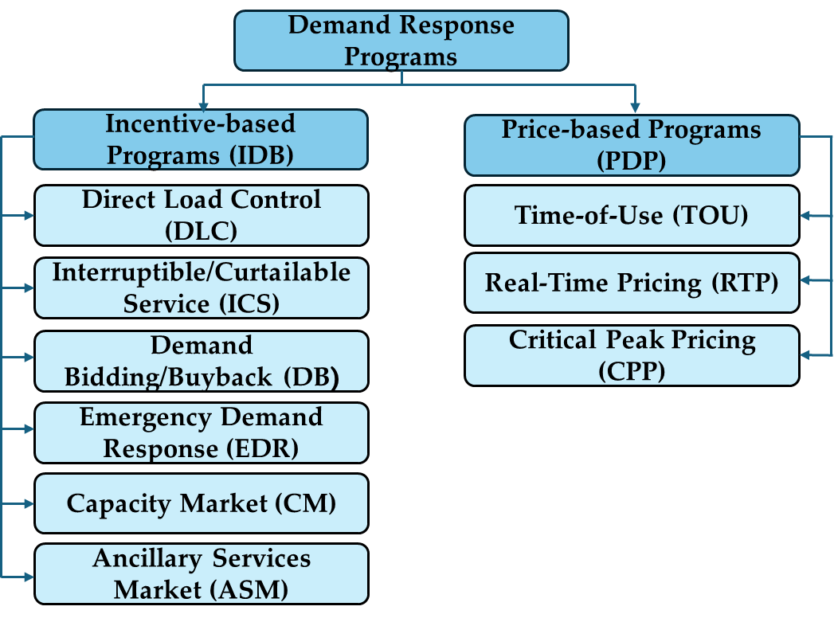

Figure 1. Demand response programs [6].

As shown in Figure 1, time-varying retail tariffs include TOU, RTP, and CPP rates, which can be characterized as “price-based” DR. In these tariff options, the price of electricity fluctuates according to changes in the basic costs of electricity production. Customers receiving these rates can reduce their electricity bills if they respond by timing their electricity use to take advantage of lower-priced periods and/or avoid using when prices are higher. Customer response is typically driven by an internal economic decision-making process, and any load shifting is entirely voluntary. Incentive-based DR programs represent contractual arrangements designed by policymakers, grid operators, and utilities to reduce demand from customers during critical times. These programs incentivize participating customers to reduce load during peak periods. Incentives may take the form of explicit bill credits or payments for pre-contractual or metered load reductions. Customer registration and response is voluntary, although some demand response programs impose penalties on customers who register but do not respond when events are announced or meet their contractual obligations. To encourage curtailment during peak demand, many companies have already implemented TOU rates or have plans to introduce such rates (Apolinario et al., 2004; Shin, 1994). The main purpose of applying such a program is to reduce the load curve during peak periods. However, some companies implemented these programs in peak periods as mandatory. Schedules can be successfully implemented if you have peak customer demand during the day. On the other hand, voluntarily maintaining the schedule for customers during the peak period (economic decision) does not create any obligation for customers to reduce the load during peak periods. In this case, the utility load factor cannot be meaningful for such applications when most customers do not have peak periods. A review of daily load curves for commercial and industrial customers is the first step towards the implementation appropriate DR program In this study, industrial and commercial field data are reviewed and analyzed, suggesting that incentive-based programs are better than pricing tariffs. Various statistical studies on daily load curves in KSA industries (a crucial part of Saudi Arabia's economic vision) have led to the classification of consumers connected to medium voltage lines in many classes of uses with use during peak or off-peak hours. According to the data classified and analyzed here, this study encourages the company to apply the appropriate solution of load management programs based on an incentive response with a penalty during peak demands.
  - Definition of Voltage Deviation

When the voltage of a power grid changes slowly (less than 1 % per second), the difference between practical and normal voltage is known as "Voltage Deviation". There are some factors that have effects on voltage level, like transmission path, supply distance, power flow dispersion, voltage management and reactive power compensation. Voltage deviation is a main factor of power quality [10]. The voltage deviation formula, as per various power quality standards, typically measures the deviation of the actual voltage from the nominal voltage and is given by:

$Voltage Deviation \left(\%\right)=\left(\frac{Vmeasured-Vnominal}{Vnominal}\right)×100$(1)

2. ENERGY MANAGEMENT MODEL

2.1. Proposed method

The proposed method has been presented in order to model the proposed structure by considering the DR. In this regard, the plan is presented along with related explanations. DR in power distribution systems, similar to all optimization problems, seeks to select the best member from a set of attainable members for which the objective is minimized. Therefore, this issue can be shown as follows:
$$minf\left(x,y\right) s.t. h(x,y)=0$$
$$g\left(x,y\right)≥0$$
$$\underline{x}≤x≤\overline{x}$$

$y_{i}∈D_{yi}, i=1,2,…,n_{y}$ (2)

The decision variables are represented by x = (x₁,x₂,...,x_{nx}) , y = (y₁,y₂,...,y_{nx}) where D_{yi} is the set of discrete values for variable y_{i}. The functions h, g, and g(x,y)=g(x,y)=(g₁(x,y),g₂(x,y),...,g_{p}(x,y))^{t} are nonlinear. Vectors $\overline{x}$∈R^{nx} and $\underline{x}$∈R^{nx} are the upper and lower bounds of variable x, respectively.

2.2. Objective function

The objective function in the load response optimization problem can be a combination of different elements. These often include minimizing the amount of active power loss (ohmic) of the power system, reducing the total network voltage deviations, the cost of program implementation, or a combination of them (multi-purpose objective function) is considered as the goal. In past articles, we have talked about issues such as minimizing costs and power losses. The minimization of voltage deviation is the topic being dealt with in this article.

2.3. Minimizing of bus voltage deviation

Improving the system voltage profile is one of the most important security goals in the normal working conditions of the power system. This issue is very important for voltage sensitive loads. If the voltage of the busbars is considered as a constraint, often the obtained voltages tend to the upper limit of the allowed range (maximum value). This will cause the power system to not have the reserve needed to provide reactive power when incidents occur. One of the effective methods to prevent this situation from happening is to choose the absolute deviation of the voltage of all buses from their desired value as an objective function. Minimizing the amount of voltage deviation of all buses will improve the voltage profile. In this case, the power system will operate with higher security and the quality of service will also increase.

Therefore, to solve the above problem, the amount of bus voltage deviation from the acceptable value is considered as an objective function as follows:

(3)

Where V_{i} is the voltage of bus i, is the desired voltage at bus i, TVD is the total voltage deviation of the power system, and N_{L} is the number of load buses in the system.

2.4. Generator Constraints

The voltage and reactive power output limits for generators are given by:

$V_{G_{i}}^{min}≤V_{G_{i}}≤V_{G_{i}}^{max}$, i = 1,..., _{NG} (4)

$Q_{G_{i}}^{min}≤Q_{G_{i}}≤Q_{G_{i}}^{max},$ i = 1,..., _{NG} (5)

where N_{G} is the number of generators.

2.1.1. Distributed Generation Constraints

Distributed generation sources are constrained as follows:

$P_{{DG}_{i}}^{min}≤P_{{DG}_{i}}≤P_{{DG}_{i}}^{max}$, i = 1,..., N_{DG} (6)

where N_{DG} is the number of distributed generators.

2.1.2. Operational Constraints

Operational constraints, including voltage and line loading constraints, are given by:

Voltage constraints

$V_{L_{i}}^{min}≤V_{L_{i}}≤V_{L_{i}}^{max}$, i = 1,..., N _{Line} (7)

$S_{L_{i}}≤{VS}_{L_{i}}^{max},$ i = 1,..., N _{Line} (8)

Where: N_{L} represents the number of load buses, V_{Li} denotes the voltage of load bus i, $V_{L_{i}}^{min}$ is minimum voltage of load bus i, and $V_{L_{i}}^{max}$ is the maximum voltage of load bus i. $S_{L_{i}}$ indicates the apparent power flow through line i, while $S_{L_{i}}^{max}$ is the maximum apparent power flow through line i. Additionally, N _{Line} refers to the number of network lines.

Load Constraints

P_{Dd} = P_{Dd1} + ${∆P}_{Dd}^{up}$ − ${∆P}_{Dd}^{down}$ (9)

$P_{Dd}^{min}$ ≤ P_{Dd} ≤ $P_{Dd}^{max}$ (10)

${∆P}_{Dd}^{up},{∆P}_{Dd}^{down}≥0$ (11)

Here, P_{Dd} represents the load power after implementing the DR program, P_{Dd1} is the load power before implementing the DR program, ${∆P}_{Dd}^{up}$ and ${∆P}_{Dd}^{down}$ are the amounts of load power increase and reduction, respectively. $P_{Dd}^{max}$ and $P_{Dd}^{min}$ are the maximum and minimum load power, respectively.

3. Optimization methods:

Optimization means defining a function and finding its inputs within the defined range so that the function is optimized to the desired value (minimum or maximum). There are three optimization methods:
- Deterministic methods
- Stochastic methods
- Hybrid methods

Deterministic methods are based on mathematical rules, sensitive to initial points, and require derivatives of objective functions, but do not guarantee reaching the optimal point. Stochastic methods rely on statistical rules, can find the optimal point, but converge slowly. Hybrid methods determine initial points for deterministic methods using stochastic methods [7].

Optimizing a nonlinear discrete function with many local optima and large dimensions is often very difficult. Various optimization methods have been used for such functions. Gradient optimization methods have been used to solve many optimization problems. Recently, interior point methods, which have faster convergence and handle inequality constraints better, have been used for optimization problems. Additionally, quadratic programming and nonlinear programming methods are also considered for solving these problems. However, all these methods struggle with nonlinear functions and constraints with many local optima. Techniques have been suggested to overcome these limitations, but they are still not suitable for solving large-scale problems.[8]

3.1. Genetic Algorithm:

In the last decade, many random search methods have been invented to solve optimization problems. GA is one of the effective methods of optimization. It was proposed by Holland in 1975, Based on the structure of genes and chromosomes [9]. This algorithm, inspired by the nature of living organisms and their hereditary role in gradual evolution, calculates the optimal value of mathematical systems. The GA starts its work with an initial population that is randomly created. This initial population consists of different designs. To specify a specific design, a string called a chromosome is used, these strings represent the features of the desired design, and on the other hand, the length of each chromosome depends on the number of optimization variables. Each of these strands consists of a number of genes.
The gene parameter is used to specify the value of each design variable, which is displayed as a string of binary numbers. GA examines these chromosomes during the process of solving problems and assigns values ​​to these chromosomes or plans according to their importance or fitness. This action is performed by the fitness function, so the higher fitness of each design means that the desired design is better. There are several ways to define the fitness function, the most common of which are as follows:

$F_{i}$ = ($f_{max}$ + $f_{min}$) - $f_{i}$ (12)

where $f_{max}$ and $f_{min}$ represent the maximum and minimum values ​​calculated for the objective function in the desired iteration, respectively, and $F_{i}$ and $f_{i}$ are the calculated value and the fitness assigned to the its plan respectively.
In the continuation of the GA, better designs are selected by the selection operator to create the next generation, and weak designs are discarded. In this algorithm, several methods are provided for the selection operator, which can be mentioned as two methods of selecting the rotating wheel and selecting the competition. After a group is chosen to produce a new generation, it is the turn of the linkage operator to combine individuals two by two, producing two new individuals each time, and this continues until a new population is formed. Although there are many ways to do the transplant, the most common one is the single point transplant.
The next operator involved in the generation process is mutation. The function of this operator is that bits of a string are selected randomly and with a small probability, and the value in them is copied. This means that if the desired bit value is zero, it changes to one, and vice versa. In fact, this action creates variety and also searches for more design space. Finally, a new generation of designs will be created, and this new generation must have a better fit than the previous generation. This process continues until the criteria for stopping the algorithm are met, such as reaching an acceptable level of answers, passing a certain predetermined time, passing a certain number of repetitions (generations), or passing a certain number of repetitions in case there is no specific improvement The issue will continue [11,12]. Figure 2 shows the flow chart of a GA [13].

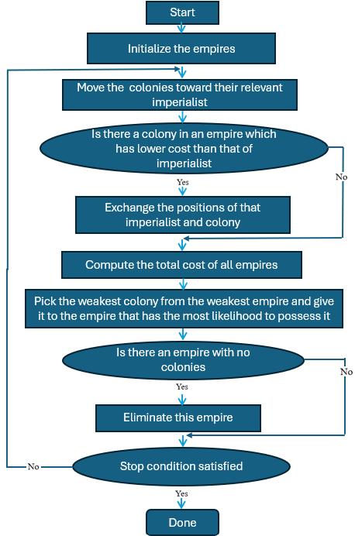

Figure 2. Flowchart of a genetic algorithm.

3.2. Imperialist Competitive Algorithm:

This method is based on the modeling of the socio-political process of colonialism. In this method, at the beginning the first population (initial countries) is created based on a random distribution. In this method, each country is a design. Then, the value of the cost function is calculated for each design, and at the end, the countries are sorted by cost in ascending order (country with the lowest cost-the first number). In the next step, it is the turn of creating empires. Each empire consists of a colonizing country and a few colonies. Each colonizing country has a certain amount of power that is obtained from the following relation:

$P_{n}=$|$\frac{C_{n}}{\sum_{i=1}^{Nimp}{C_{i}}}$| (13)

In the above formula, $C_{n}$is the normalized cost of the colonizing country, $C_{i}$ is the cost of the colonizer, and $max${ $c_{i }$} is the cost of the first colony.

The normalized cost of each colonizing country is calculated based on the following relation: $C_{n}=max\left\{c_{i}\right\}-c_{n}$ (14)

After the colonizer countries are selected, the number of colonies of each colonizer needs to be obtained, and to do this. The following relation is used:

$N.C_{n}$= round {$P_{n}$.( $N$ col)} (15)

After determining the number of colonies, the colonies are distributed among the empires with a random distribution. In the method of colonial competition, each colonizing country tries to bring its colonies closer to its position, which is called attraction policy. In order to prevent premature convergence, revolutions are used in the colonies, in such a way that we first consider a random number for each colony, it is then compared with the revolution rate. If the random number is lower than the revolution rate, the colony can undergo sudden changes. One of these changes can be the change of one of the design variables in this country. Two empires may find themselves in a situation where their colonists are located close to each other. In this case, the two empires will merge.
- Determining the distance vector between two colonists

Distance Vector=($X_{i}$)imp1-($X_{i}$)imp2
- Determining the distance between two colonists

Distance = $\sqrt{\sum_{1}^{nVar}{\{Distance Vector}\}^{2}}$
- Determining the threshold distance
- Threshold Distance = Uniting Threshold* $\sqrt{\sum_{1}^{nVar}{(X_{u_{i}}-X_{l_{i}}})^{2}}$

In the above $equation, X_{u_{i}},X_{l_{i}}respectively$ are the maximum and minimum value of the i-th design variable. If the distance between two colonizers is less than the integration threshold (Threshold Distance), the empire whose colonizer costs more will join another empire as a colony.

After the above processes, each empire (including a colonizer and a number of colonies) is sorted in ascending order based on cost, and if a colony has a lower cost than its colonizer, it will take its place. The weakest empire, its weakest colony should give to another empire. Determining the total cost of empires (which is based on the cost of the colonizing country and a coefficient of the costs of the colonies of that empire):

Empire Cost Calculation:

EmpireCost = ImpCost + ζ ⋅ mean(ColoniesCost)

Normalized Cost of Each Empire:

${(NormEmpCost)}_{i}$ = max (EmpireCost) - ${(EmpCost)}_{i}$

In these equations: EmpireCost represents the total cost associated with an empire, ImpCost denotes the cost of the imperialist, ζ is a constant factor, mean(ColoniesCost) is the average cost of the colonies, max(EmpireCost) indicates the maximum cost among all empires, ${(EmpCost)}_{i}$ is the cost of the i-th empire.

And after that, the probability of taking over each empire is determined by the following relations:

$P_{n}$ = | $\frac{(NormEmpCost)i}{\sum_{1}^{NoImp}{\left(NormEmpCost\right)i} }$| (16)

When an empire has no colonies, its colonizing country must become a colony of one of the empires. The process of assigning that colonizer to other empires is similar to the previous step. At the end of each iteration, the convergence condition is checked and if this condition is met, the algorithm stops. Otherwise, we have to continue repeating [14,15]. Figure 3 is shown the flowchart of ICA.

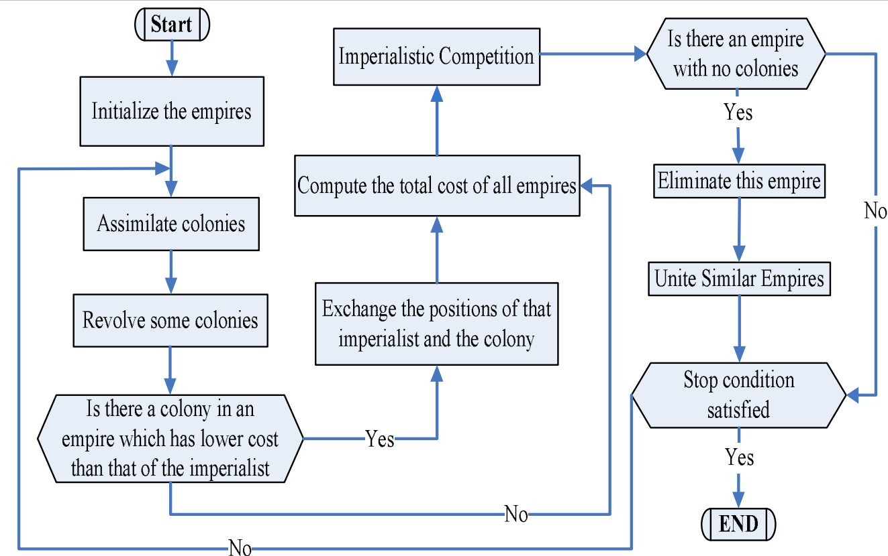

Figure 3. Flowchart of the Imperialist Competitive Algorithm [16].

A comparison of different optimization techniques is listed in Table 1.

Table 1: Comparison of Optimization Techniques.
Technique | Key Features | Advantages | Drawbacks
Deterministic Methods | Mathematical rules, requires derivatives | Fast convergence | Sensitive to initial points, may not reach global optimum
Stochastic Methods | Statistical rules, random searches | Can find global optimum, handles non-linearity | Slow convergence
Hybrid Methods | Combination of deterministic and stochastic | Balances speed and accuracy | Complexity in implementation
Genetic Algorithm (GA) | Inspired by natural selection, uses fitness function | Handles complex problems, flexible | May converge slowly, computationally intensive
Imperialist Competitive Algorithm (ICA) | Inspired by imperialistic competition | Efficient for large-scale problems | Can get trapped in local optima
Hybrid GA-ICA | Combines GA and ICA techniques | Improves convergence and accuracy | Increased computational complexity

3.3 Explanation of the Hybrid Process

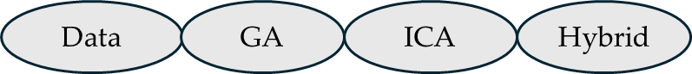

Figure 4. Optimization process sequence

Based on Fig4, the initial population for the GA is either randomly generated or based on some heuristic. The same initial population serves as the starting point for the ICA. Then Both GA and ICA require fitness evaluations. For GA, fitness is used to select parents and generate offspring. For ICA, fitness helps in assigning colonies to imperialists.
    - Genetic Algorithm Operations
- The best individuals are selected based on fitness, ensuring that high-quality solutions have a better chance of being chosen.
- Produces new candidate solutions by combining features from two or more parents, potentially creating more optimal solutions.
- Introduces random variations to ensure diversity and prevent premature convergence.
    - Imperialist Competitive Algorithm Framework

1. Represent high-quality solutions from the current population.

2. Initially assigned to imperialists based on proximity or fitness.

3. Imperialists influence their colonies, and colonies are moved towards their imperialists. Imperialists also competed to acquire more colonies.

3.3.3 Hybrid Integration

GA for Local Search: Genetic operators are used to refines solutions, enhancing their quality on a local scale.

ICA for Global Search: Ensures global exploration by adjusting colony positions and maintaining the search space varied.

At the end, the hybrid model alternates between GA and ICA processes to further refine solutions. It continues until a stopping criterion, like reaching a maximum number of iterations or achieving a desired accuracy of solutions, is met.

4. SIMULATION RESULTS

The network under study, includes 33 main buses. Bus number 1 is connected to the main network and the required power of the loads is obtained through this bus from the main network. The permissible range of voltage change of the generators is assumed to be between 0.95 and 1.05 per unit. Also, the active and reactive load of the whole network are 3.715 MW and 1.8 MVAR, respectively. The operating voltage of this network is 12.66 kV. The 33 buses grid includes resistance, reactance, line susceptance and the amount of permissible power passing through the lines are given. The base load value is the values presented in [17].

In the network under consideration, it is assumed that 5 buses of the network are industrial loads, 10 buses are commercial loads, and the others are residential loads. The final result obtained with the aim of minimizing voltage deviation considering the power flowing in the lines will be examined using both the GA and ICA.

A voltage near 1 per unit signifies enhanced system stability. It indicates that the system is functioning properly with fewer voltage fluctuations. Furthermore, lower losses translate to higher efficiency and cost savings. Many electrical devices are designed to operate at voltages around 1 per unit. Lower voltages can lead to reduced efficiency and potential damage to equipment. Additionally, lower voltage can increase the current in the system, potentially causing overheating and even fire. Maintaining a voltage close to 1 per unit helps mitigate these risks [18, 19]. Here, the ultimate goal of minimizing voltage deviation is divided into 4 scenarios:
- Initial State: The state of the network without performing any management (implementation of the load response program) is investigated (see Figure 4). This initial state is considered as the zero scenario. As observed, in this case, the voltage profile is between 0.95 to 1 per unit. Now for example, the voltage magnitude of bus number 18 at H20 is 0.95294 per unit, which should be improved after optimization algorithms.

Figure 5. Voltage profile of the network at different hours of the day in the initial state.

- First Scenario: The first scenario is examined considering optimization using the ICA. As expected, the voltage profile became closer to 1 per unit and in the bus number 18 at H20 is reached 0.96866 p.u (see Figure 5).

Figure 6. Voltage profile of the network at different hours of the day in the First scenario

- Second Scenario: At this stage, we continue optimization using the GA (se Figure 6). In this case, the voltage at H20 and bus 18 is 0.97310 p.u. This means that so far, the GA has performed better than the ICA.

Figure 7. Voltage profile of the network at different hours of the day in the second scenario

- Third scenario: In this stage, the same operations as the previous stage are performed using a combination of the GA and ICA. In Figure 7, it is observed that the voltage at H20 and bus 18 is 0.97697.
Figure 8. Voltage profile of the network at different hours of the day in the third scenario.

A comparison between different techniques for buses 27, 28 and 31 at hours between 21 to 24 are also listed in Table 2.
Table 2. Comparison between different techniques for buses 27, 28 and 31 at specific times.
- Results at bus 27
Technique | H21 | H22 | H23 | H24
Base case | 0.96888 | 0.97270 | 0.97521 | 0.97945
ICA | 0.97978 | 0.97927 | 0.98237 | 0.98392
GA | 0.98142 | 0.98497 | 0.98625 | 0.98894
Hybrid | 0.98116 | 0.98482 | 0.98635 | 0.98929

- Results at bus 28

Technique | H21 | H22 | H23 | H24
Base case | 0.96330 | 0.96775 | 0.97068 | 0.97564
ICA | 0.97599 | 0.97560 | 0.97906 | 0.98044
GA | 0.97778 | 0.98216 | 0.98367 | 0.98660
Hybrid | 0.97798 | 0.98224 | 0.98368 | 0.98704

- Results at bus 31
Technique | H21 | H22 | H23 | H24
Base case | 0.95605 | 0.96148 | 0.96505 | 0.97108
ICA | 0.97174 | 0.97110 | 0.97548 | 0.97651
GA | 0.97367 | 0.97923 | 0.98113 | 0.98388
Hybrid | 0.97419 | 0.97925 | 0.98130 | 0.98471

5. Conclusion and Future Works

This paper presents a comprehensive evaluation of voltage deviation improvement in microgrid operations through the integration of DRs strategies optimized by ICA and GA. These algorithms prove beneficial in scenarios with dynamic demand patterns and varying operational constraints. We have implemented the proposed method on a 33-Bus IEEE sample network to reach the aim. The network was initially considered without any optimization, then performed with the optimization techniques using the ICA and GA, and finally obtained and compared the results using a hybrid of both algorithms. As observed, the GA provided better results compared to ICA, and the hybrid model further improved the voltage profile as it has more features that will help to improve the performance of the optimization problem.

It is recommended for future research to use another intelligent algorithm to see the manner of voltage deviation. Additionally, the impact of DRs on different load types can be evaluated, or improving simulation models to account for diverse parameters such as seasonal variations and consumer behavior could lead to more accurate results.

References
- Eldali, Fathalla, et al. "Cost-benefit analysis of Demand Response programs incorporated in Open Modeling Framework." 2016 IEEE power and energy society general meeting (PESGM). IEEE, 2016.‏
- Venkatesan, Naveen, Jignesh Solanki, and Sarika Khushalani Solanki. "Residential demand response model and impact on voltage profile and losses of an electric distribution network." Applied energy 96 (2012): 84-91.‏
- Ullah, Kalim, et al. "Optimization of demand response and power-sharing in microgrids for cost and power losses." Energies 15.9 (2022): 3274.‏
- Le, Le Thi, et al. "A comparative study of PSO-ANN, GA-ANN, ICA-ANN, and ABC-ANN in estimating the heating load of buildings’ energy efficiency for smart city planning." Applied Sciences 9.13 (2019): 2630.‏
- Purlu, Mikail, and Belgin Emre Turkay. "Optimal allocation of renewable distributed generations using heuristic methods to minimize annual energy losses and voltage deviation index." IEEE Access 10 (2022): 21455-21474.‏
- Dehghani, Hamed, and Behrooz Vahidi. "Transformers loss of life management in smart distribution networks using a new hybrid method based on optimal demand response programs and cost–benefit analysis." Electrical Engineering 104.4 (2022): 1951-1966.
- de Moraes, Lucas Borges, Rafael Stubs Parpinelli, and Adriano Fiorese. "Application of deterministic, stochastic, and hybrid methods for cloud provider selection." Journal of Cloud Computing 11.1 (2022): 5.‏
- Zhang, Jin-Xi, Kai-Di Xu, and Qing-Guo Wang. "Prescribed performance tracking control of time-delay nonlinear systems with output constraints." IEEE/CAA Journal of Automatica Sinica 11.7 (2024): 1557-1565.‏
- HOLLAND, John H. Adaptation in natural and artificial systems: an introductory analysis with applications to biology, control, and artificial intelligence. MIT press, 1992.‏
- LI, Lanfang, et al. Analysis on voltage deviation inactive distribution network and active voltage management. In: 2014 China International Conference on Electricity Distribution (CICED). IEEE, 2014. p. 1610-1614.‏
- Kothari, Dwarkadas Pralhaddas. Power system optimization. In: 2012 2nd National conference on computational intelligence and signal processing (CISP). IEEE, 2012. p. 18-21.‏
- Ahmed, M., et al. Optimal genetic-sliding mode control of VSC-HVDC transmission systems. Energy Procedia, 2015, 74: 1048-1060.‏
- LE, Le Thi, et al. A comparative study of PSO-ANN, GA-ANN, ICA-ANN, and ABC-ANN in estimating the heating load of buildings’ energy efficiency for smart city planning. Applied Sciences, 2019, 9.13: 2630.‏
- Ghasemi, Mojtaba, et al. "Multi-objective optimal power flow considering the cost, emission, voltage deviation and power losses using multi-objective modified imperi-al-ist competitive algorithm." Energy 78 (2014): 276-289.‏
- Alvarado-Reyes, Sergio, Paul Villar-Yacila, and Hugo Fiestas. "Imperialist com-petitive algorithm applied to the optimal integration of photovoltaic distributed gen-eration units into a microgrid." e-Prime-Advances in Electrical Engineering, Electron-ics and Energy 2 (2022): 100086.‏
- Jahani, R., et al. ICA-based Allocation of DGs in a Distribution System. American Journal of Scientific Research, 2011, 33: 64-75.‏
- N. Rugthaicharoencheep, S. Nedphograw, and W. Wanaratwijit, “Distribution System Operation for Power Loss Minimization and Improved Voltage Profile with Distributed Generation and Capacitor Placements”, 2011 IEEE 4th International Conference on Electric Utility Deregulation and Restructuring and Power Technologies (DRPT), pp. 1185–1189, 2011.
- Purlu, Mikail, and Belgin Emre Turkay. "Optimal allocation of renewable distributed generations using heuristic methods to minimize annual energy losses and voltage deviation index." IEEE Access 10 (2022): 21455-21474.‏

